**Task 1: Develop a Simple College Website including all the Department Information using HTML5 and CSS3.**

**Aim:**

To develop a simple web site including all the information using HTML5 and CSS3

# Procedure:

1. Install MS Visual studio code
2. Create HTML File
3. Create CSS File
4. Link CSS File in HTML File using link tag
5. Write necessary code

# Program:

# index.html

<!DOCTYPE html> <!-- The new doctype -->

<html>

<head>

<meta http-equiv="Content-Type" content="text/html; charset=utf-8" />

<title>Task 1</title>

<link rel="stylesheet" type="text/css" href="styles.css" />

</head>

<body>

<section id="page">

<header>

<hgroup>

<img src="logo.png" width=30%>

<h3>Vel Tech</h3>

</hgroup>

<nav class="clear"> <!-- The nav link semantically marks your main site navigation -->

<ul>

<li><a href="#article1">About Us</a></li>

<li><a href="#article2">CSE</a></li>

<li><a href="#article3">Placement</a></li>

</ul>

</nav>

</header>

<section id="articles">

<div class="line"></div>

<article id="article1">

<h2>Photoshoot Effect</h2>

Develop a Simple College Website including all

the Department Information using HTML5 and

CSS3.

Task: 1

<div class="line"></div>

<div class="articleBody clear">

<figure>

<a href=""><img src="download.jpg" width="620" height="340"

/></a>

</figure>

<p>Vel Tech is well-known for its renowned educational practices, which has

been recognized and endowed with several awards. The founders of the Institution, Col. Prof.

Vel. Dr. R. Rangarajan Chancellor & Founder President and Dr. Sagunthala Rangarajan

Foundress President believes in Education for All despite their financial means which will

promote and uplift the society. </p>

<p>In accord to their vision, Vel Tech Mahatma Gandhi Scholarship scheme

was started and has supported students since the inception. Vel Tech has bestowed 9500

scholarships worth approximately Rs. 35 Crores until 2019. </p>

</div>

</article>

<div class="line"></div>

<article id="article2">

<h2>Sweet AJAX Tabs</h2>

<div class="line"></div>

<div class="articleBody clear">

<figure>

<img src="download1.jpg" width="620" height="340" /></a>

</figure>

<p><b>We are Passionate. Doers in Innovative Engineering

Education</b></p>

<p>

Global Alliances of Vel Tech has working International Relations with more than 390

Institution across 30 countries and has entered in the Memorandum of Understanding (MoU)

with 120 Institutions for various Academic and Research exchange activities. Students,

Faculty members, and Researchers get the collaborative platform for Academic projects,

explore leading best practices and Research work with International Universities. Vel Tech

believes that there are no boundaries in the pursuit of knowledge. Through these strategic

alliances with International Universities, the standard of education at Vel Tech would be on

par with the best in the world. </p>

</div>

</article>

</section>

<footer> <!-- Marking the footer section -->

<div class="line"></div>

<p>Copyright 2023 - veltech.edu.in</p>

<a href="#" class="up">Go UP</a>

</footer>

</section>

</body>

</html>

# styles.css

*{

    /* Universal selector: */ margin:0;

    padding:0;

 }

    header,footer, article,section, hgroup,nav, figure

    {

     /* Giving a display value to the HTML5 rendered elements: */ display:block;

    }

    body{

        font-size:0.825em;

        color:#fcfcfc;

        background-color:#355664;

        font-family:Arial, Helvetica, sans-serif;

    }

    /* Hyperlink Styles: */ a, a:visited {

        color:#0196e3;

        text-decoration:none; outline:none;

        }

a:hover{

text-decoration:underline;

}

a img{

    border:none;

}

/* Headings: */

h1,h2 {

    font-family:"Myriad Pro","Helvetica Neue",Helvetica,Arial,Sans-Serif; text-shadow:0 1px 1px black;

}

h1{

/* The logo text */ font-size:3.5em; padding:0.5em 0 0;

text-transform:uppercase;

}

h2{

    font-size:2.2em; font-weight:normal;

    letter-spacing:0.01em; text-transform:uppercase;

}

p{

    line-height:1.5em; padding-bottom:1em;

}

.line{

/* The dividing line: */ height:1px;

background-color:#24404c; border-bottom:1px solid #416371;

margin:1em 0; overflow:hidden;

}

/* Article styles: */

#page{

    width:960px; margin:0 auto; position:relative;

}

article{

    background-color:#213E4A; margin:3em 0; padding:20px;

    text-shadow:0 2px 0 black;

}

figure{

    border:3px solid #142830; float:right;

    height:300px; margin-left:15px; overflow:hidden; width:500px;

}

figure:hover{

    -moz-box-shadow:0 0 2px #4D7788;

-webkit-box-shadow:0 0 2px #4D7788; box-shadow:0 0 2px #4D7788;

}

figure img{

    margin-left:-60px;

}

/* Footer styling: */

footer{

    margin-bottom:30px; text-align:center; font-size:0.825em;

}

footer p{

    margin-bottom:-2.5em; position:relative;

}

# Output:

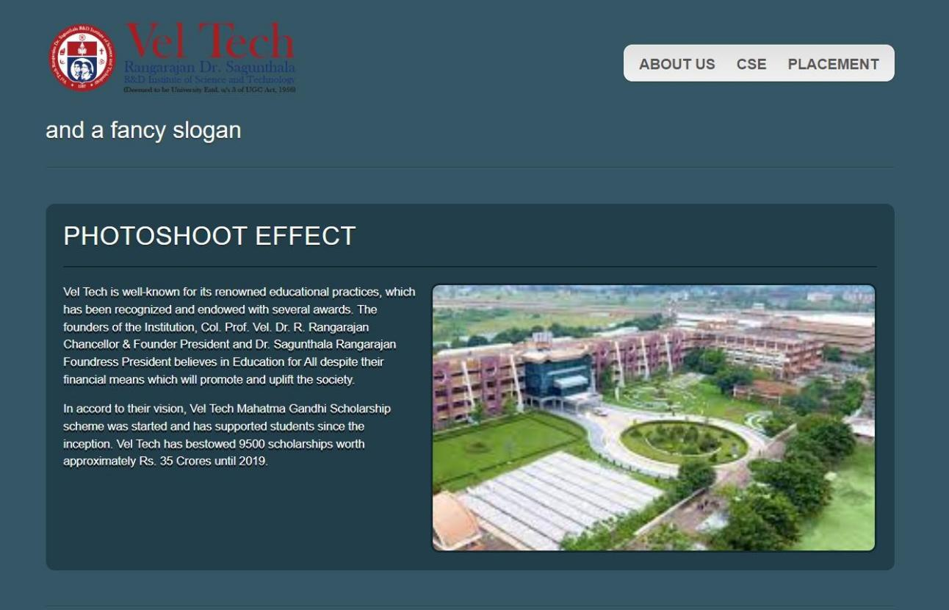

# Result:

# Thus the above program was executed successfully and the output was verified.